**Academic Year: 2023-24 Semester: V Class / Branch: TE IT**

**Subject: DevOPs Lab (DL)**

**Subject Lab In-charge: Prof. Sonal Jain/Prof. Neha Deshmukh**

**EXPERIMENT NO. 09**

**Aim: To build an image for a sample web application from a docker file using various docker file instructions**

**Theory:**

Creating a Docker Image for your Application:

This is the recommended workflow for creating your own Docker image for your application:

1. Write a Dockerfile for your application.
2. Build the image with docker build command.
3. Host your Docker image on a registry.
4. Pull and run the image on the target machine.

Docker builds images automatically by reading the instructions from a Dockerfile. It is a text file that contains all commands needed to build a given image.

**Step1: Create a directory which will be created as image to run as a container.**

mkdir myapp

cd myapp

touch index.html



**Step 2:** Write a simple html program of Hello World inside index.html or we can write simple command like

echo “Hello World!!”

**Step 3**: Create a Dockerfile to write docker instruction using touch command (Note: no extension will be provided to Dockerfile)

touch Dockerfile

**Step 4:** Write following instructions insider Dockerfile

FROM nginx

COPY index.html /usr/share/nginx/html

**Step 5**: Get docker information if docker is running successfully

docker info

(Note if output is not generated then type command)

Sudo service docker start

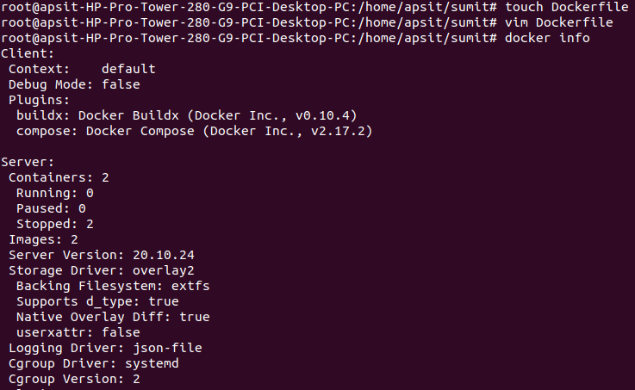

**Step 6:** To build docker image of “myapp” directory which we have created on local machine.

Docker build -t myapp .

Step 6: Once we start building images, docker will automatically pulling nginx from docker hub using the instruction written in Dockerfile.

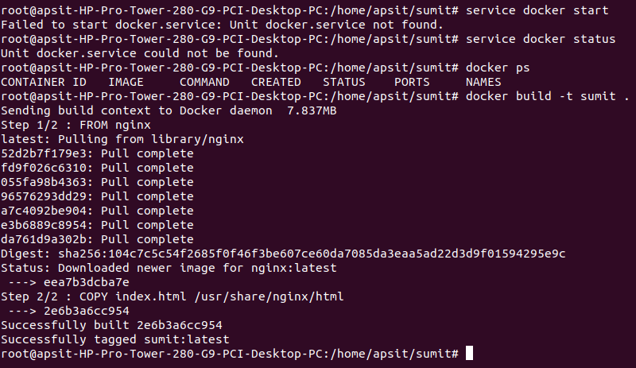

**Step 7:** Check whether image has been created and listed.

docker images

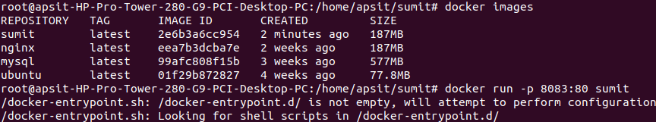

**Step 8:** To run the container of sample web application of “myapp” (Note: Choose any port no. like 8082 or 8083 which must not clash with any other running application)

docker run -p 8083:80 myapp

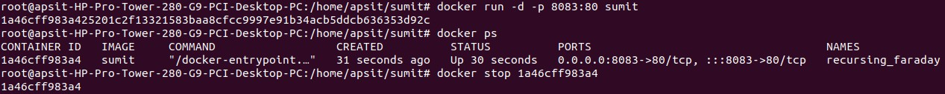

**Step 9:** Verify the web application created through container on given port number of local host.

localhost:8083

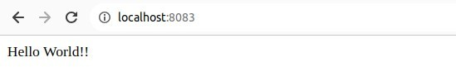

**Conclusion:** In the previous experiment, we used docker to pull images that were already built,but in this experiment we created our own images by using docker file instructions for a sample web application using docker. We have used nginx for the same as nginx is normal web server free of cost.